Preparing
the Way
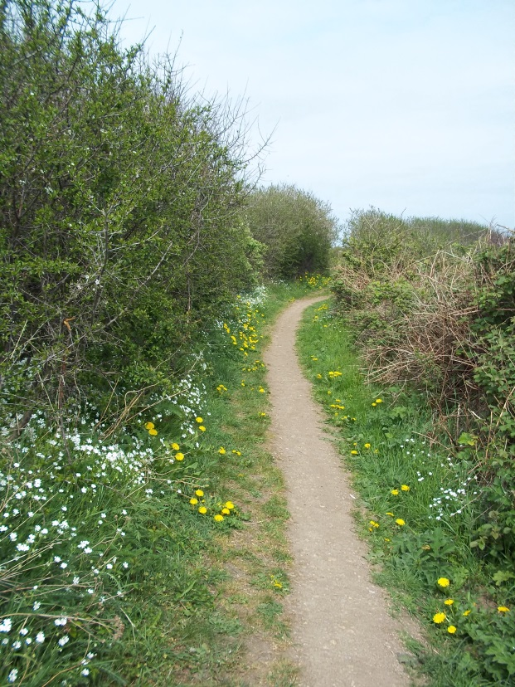
A liturgy to mark the beginning of our Journey
Forward Together in Hope
Opening Responses
Reader We gather in the name of the Father:
All Who created us his sons and his daughters,
and placed us on the earth
to live the journey of a lifetime
and gave us companions to share the way.

Reader We gather in the name of the Son:
All Who calls disciples and friends to follow him –
along old paths and new ways –
to new encounters and to relived memories –
walking with us on the way to the Kingdom.

Reader We gather in the name of the Holy Spirit:
All Who inspires and cajoles,
who reassures and challenges
all whom the Lord calls –
encouraging them along the path that leads into a future
they may not yet be able to imagine –
or believe in.

All We gather in the Name of the Father, and of the Son, and of the Holy Spirit. Amen

Scripture Reading – Mark 1: 16-20)
Jesus calls the first disciples

Sung Response

Reflection

Scripture Reading – Matthew 28: 16-20
“Behold I am with you until the end of time…”

Going Forward Together in Hope

Closing Prayer
Reader Lord Jesus, you honour all that is part of our past
and our heritage
but from the beginning, have called men and women to travel
to journey –
to follow you into places filled with fun and laughter
and to darker and more frightening places.
But always, you were with them –
leading them forward –
leading them together
leading them in hope.

All Bless us as we embark upon this journey –
our leaders and our companions
as we take our place in this great procession through history
joining those in our past and our future
travelling forward together – with you – in hope:

In the name of the Father, the Son and the Holy Spirit.

Closing Song The Summons… (or other option

© Diocese of Hexham and Newcastle March 2015
Also available in other formats

