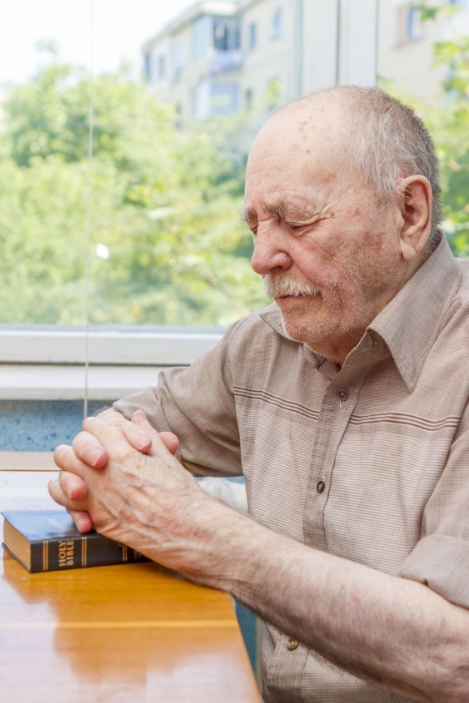
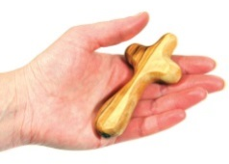
Anchors
Rite of Commissioning
those whose ministry is to pray at home
Leader Dear friends, we are delighted to welcome you
and are grateful that you are able to be with us today.
You have agreed to take on the role of a parish anchor.
This is a strange title – and probably unique to our Diocese!
It reminds us of men and women – called anchorites or anchors
who gave their lives to prayer in small annexes of their local church.

It also reminds us of anchors –
which hold ships steady in harbours or in storms.

And it might remind us of the anchor men and women
who hold television or radio programmes together.

The name is a sign of the indispensable role
you play in the life of our community
and, particularly, during this journey of renewal.
Are you willing to take on this ministry of anchor to our parish?
Anchor(s) We are.

Short Reading
Jesus said,
‘Whenever you pray, go into your room and shut the door
and pray to your Father who is in secret;
and your Father who sees in secret will reward you.’

A sung response might be possible here…

Making the Commitment of Prayer
Leader Will you pray for those of us who are charged
with examining and reflecting
on the information about our parish/ community?
Anchor(s) We will.

Leader Will you pray the Forward Together in Hope prayer each day,
for your parish (N…),
its clergy (N….)
Its lay people,
and our school (N…)
and (any other significant group or organisation)?
Anchor(s) We will.

Where a holding cross is to be given:
Leader The journey ahead will have its times of joys and sorrows.
We ask that you accept this holding cross…
and when you hold it,
that you bring all the pain and stress
to the foot of the Lord’s cross,
and pray for his powerful and healing love
to be poured upon us
as we look for the resurrection he promises.
Crosses distributed
May God bless these crosses and those who will pray with them,
The Father, the Son and the Holy Spirit.
All Amen.

Where a candle is to be given:
Leader The journey ahead will have its times of light but also of darkness. We ask that you accept this candle to use in your prayer.
When you light it,
give thanks to God for the light and joy
and pray that he who is the Light of the World
will bring light and hope into the times of darkness and anxiety.

Candles distributed
May God bless these candles and those who will pray with them
The Father, the Son and the Holy Spirit.
All Amen.
Leader Let us now pray our Forward Together in Hope prayer.

Glory be to the Father –
in whom we live and move
and have our being.

Glory be to the Son –
whose name we bear and who
calls each of us to be his disciples;
to build his Kingdom and to go out
into the world and bear its fruit.

Glory be to the Holy Spirit –
pouring out grace and guidance,
forming us and renewing us.
Inspire us all in the Diocese of Hexham and Newcastle
to live the Gospel,
to be open to change
and to move forward together in hope.
Amen
© Diocese of Hexham and Newcastle—March 2015
Available in other formats

